**Data Types – Week 1**

**Continuous** – data refers to variables that can take on any numerical values and the scale can be reasonably divided into increments and pieces, including fractions and decimals.

**Histograms** – continuous data distribution and bins the data.

**Scatterplot** – two continuous data points

**Discrete** – Non-negative integers and cannot be divided into smaller increments (i.e. count of a characteristic i.e. # of blues eyes)

**Bar Charts** – count of distinct value

**Box Plot** – dist of numeric values to compare groups and find symmetry and outliers.

**Categorical** – Data fits into categories. As an analyst, we are interested in the ratios and proportions of this data.

**Pie Charts** – good for small number of unique values.

**Stacked Bar Charts –** part to whole ratios

**Nominal** – a type of categorical data that represents variables with no inherent order or structure. Not ordered groups, where the group labels serve as unique identifiers for each data point. (i.e. Brown vs Blue eyes). No ranking order, the categories themselves do not have any mathematical relationship or significance.

**Ordinal** – Type of categorical data that represents variables with an inherent order or structure. Categorizes data points into distinct and ordered groups, where the groups labels serve as unique identifiers. (i.e. grading systems A, B, C, D, F; shirt sizes; Education Level) Categories will have a meaningful order, and the difference between categories is not always equal. Basic comparisons and rankings but cannot be used to make accurate mathematical comparisons.

**Binary** – Type of data that represents variables with only two possible values, typically represented as 0 and 1 or “yes” and “no”. Two distinct and non-overlapping groups.

**Qualitative Data** – Type of data that deals with the qualities or characteristics that are descriptive or non-numerical in nature. It is often used to describe the attributes, characteristics, or traits of individuals.

**Quantitative Data** – Type of data that deals with numerical measurements or counts.

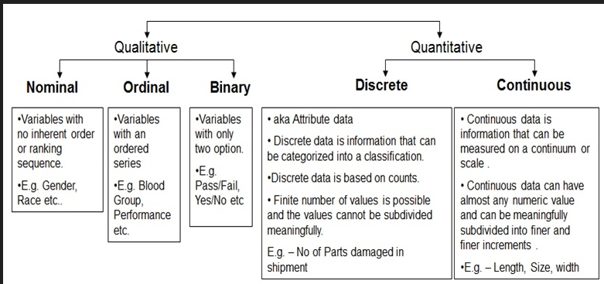

**Why is Data Visualization Important?**

1 – Better understanding of data

2 – Improved Communication

3 – Increased Insight

4 – Increase Decision Making

5 – Cost Effective

Other types of graphs:

**Violin Graphs –** Plots are similar to box plots, but also show the density of the data in each dataset.

**Heat Maps** –

**Time Series Plotting** - Data visualization of change over time

**Geographical** – Mapping data onto a geographical map. Pop data, Weather data